## **Scenario 2: Bonus Scheme for Employees**

### **Objective**

Create a **stored procedure UpdateEmployeeBonus** that:

* Takes a **department name** and **bonus percentage** as parameters
* Increases the salary of all employees in that department by the given bonus percentage
* Commits the changes and displays a success message

## **Approach**

* Use an **UPDATE statement with a WHERE clause** to select employees of the given department
* Increase salary using:

Salary = Salary + (Salary * (Bonus% / 100))

* Commit the changes
* Use DBMS_OUTPUT.PUT_LINE to show a message

## **Stored Procedure Code**

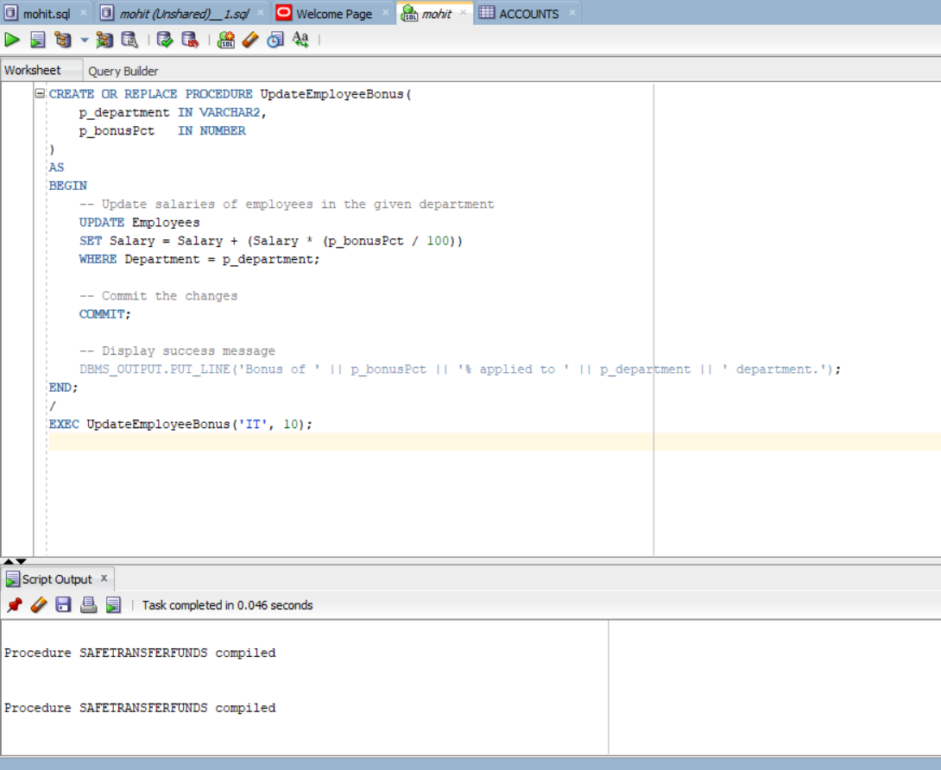

## **📌 ✅ How to Call the Procedure**

EXEC UpdateEmployeeBonus('IT', 10);

## **Behavior**

|  |  |
| --- | --- |
| **Department** | **Action** |
| Matches input | Salary increased by given percentage |
| Others | No change |

**DBMS Output:**

Bonus of 10% applied to IT department.